**Hart Publishing is delighted to announce the publication of**

**‘Defences in Unjust Enrichment’**

**edited by Andrew Dyson, James Goudkamp and Frederick Wilmot-Smith**

We are pleased to offer you **20% discount** on the book

To order online with your **20% discount** please click on the link below the title and then click on the ‘pay now’ button on the right hand side of the screen. Once through to the ordering screen type ref: **CV7** in the voucher code field and click ‘apply’

Alternatively, please contact Hart Publishing’s distributor, Macmillan Distribution Limited, by telephone or email (details below) quoting ref: **CV7**

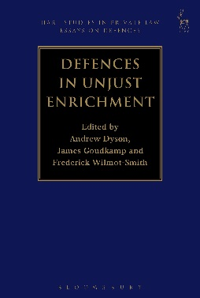**Defences in Unjust Enrichment**

Critical and Comparative Essays

*Edited byndrew Dyson, James Goudkamp*

*and Frederick Wilmot-Smith*

This book is the second in a series of essay collections on defences in private law. It addresses defences to liability arising in unjust enrichment. The essays are written from a range of perspectives and methodologies. Some are doctrinal, others are theoretical, and several offer comparative insights. The most important defence in this area of the law, change of position, is addressed in detail, but many other defences are treated too, as well as the interrelations between these defences within the law of unjust enrichment. The essays offer novel claims and ways of looking at problems in this challenging area of legal study.

***Andrew Dyson*** is an Assistant Professor in Private Law at the London School of Economics and Political Science.

***James Goudkamp*** is a Fellow of Keble College and an Associate Professor in the Oxford Law Faculty.

***Fred Wilmot-Smith*** is a Prize Fellow at All Souls College, Oxford and Lecturer in Law at Balliol College.

[Please click here to view the table of contents for this book](http://www.hartpub.co.uk/pdf/9781849467254.pdf)

**BOOK DETAILS**

January 2016 360pp Hbk 9781849467254 RSP: ~~£75~~

**Discount Price: £60**

[**Order Online**](http://www.hartpub.co.uk/books/details.asp?isbn=9781849460033)

If you would like to place an order you can do so through the Hart Publishing website website (link below). To receive the discount, please click on the ‘pay now’ button on the right hand side of the screen. Once through to the ordering screen type ref: **CV7** in the voucher code field and click ‘apply’.

[**http://www.hartpub.co.uk/BookDetails.aspx?ISBN=9781849467254**](http://www.hartpub.co.uk/BookDetails.aspx?ISBN=9781849467254)

**Alternatively, please contact Hart Publishing’s Distributor, Macmillan Distribution Limited, by telephone or e-mail and quote reference CV7 when placing your order.**

Macmillan Distribution (MDL), Brunel Road, Houndmills, Basingstoke, RG21 6XS, UK

**UK ORDERS:** Tel: +44 (0)1256 302692    Fax: +44 (0)1256 812521 / 812558      E-mail: [direct@macmillan.co.uk](mailto:direct@macmillan.co.uk)

**EU AND ROW ORDERS:** Tel: +44 (0)1256 329242    Fax: +44 (0)1256 842084    E-mail: [export@macmillan.co.uk](mailto:export@macmillan.co.uk)